**Hillingdon Manor School: Careers Strategy**

**Introduction**

We are working continuously to improve and develop the focus of careers within School. Our aim is to excel in meeting all eight of the [Gatsby Benchmarks](https://www.careersandenterprise.co.uk/schools-colleges/gatsby-benchmarks) and follow the [CDI Career Development Framework](https://www.thecdi.net/new-career-development-framework) (select the links for further information).

At the heart of our strategy, pupils are believed in and this in turn, will encourage self-belief.

**What are we doing well?** *(GBM: Gatsby Benchmarks)*

1. **GBM1:** We now have a Careers Programme in place.
2. **GBM4:** Teachers are very good linking curriculum to careers and this continues to improve with additional resources.
3. **GBM5:** We continue to deliver encounters with employers and build an employer relationship bank.
4. **GBM6:** We have an recognised successful internal work experience programme. We are building relationships for external work experience placements.
5. **GBM7:** We are building strong relationships with FE settings both locally and further afield, settings are invited to School to meet with students and families.
6. **GBM2 and 8:** We have an established impartial Careers Advisor working with our students. In 2022-23 89.6% of students Y11 and higher met with the Advisor.
7. We have a named, trained School Careers Lead, Emma Cobbold.
8. “Careers logo” (chosen from an in-house school competition) designed by a student.
9. Destinations Data is shared with students and families.

**Areas for development:**

1. The Careers Programme is the portal for raising profile of careers for parents and carers, students, teacher, employers – there needs to be a focus on embedding and sharing; this is a priority (including via online channels and the school website).
2. Where there are good practices across the School, these need to be appropriately recorded, repeated and shared – with peers, students, parents and carers, employers.
3. School Governor for Careers to be assigned.
4. In-house School (staff) “Careers Champions Team” to be developed.

**Careers Policy**

**Imagine. Believe. Do.**

**Careers provision is not simply an opportunity, it is an absolute entitlement for all our students.**

Our aim is that all our students are ready for the next stage of education, employment or training. Where relevant, students will gain qualifications that allow them to go on to destinations that meet their interests, aspirations and intentions. This will have been embedded into their curriculum from the beginning of their educational journey at HMS. We will have the highest of expectations for our students; that they will contribute to society in a meaningful and appropriate way.

In line with our school vision, we also recognise we have a duty to promote awareness and understanding of autism in the community.

**Our Student Entitlement**

We will continue to challenge stereotypes with careers related activities as well as resources displayed around the school. We will measure impact by keeping careful records of specific career and enterprise related learning which will take place in addition to being embedded into the curriculum. We will always be considerate of:

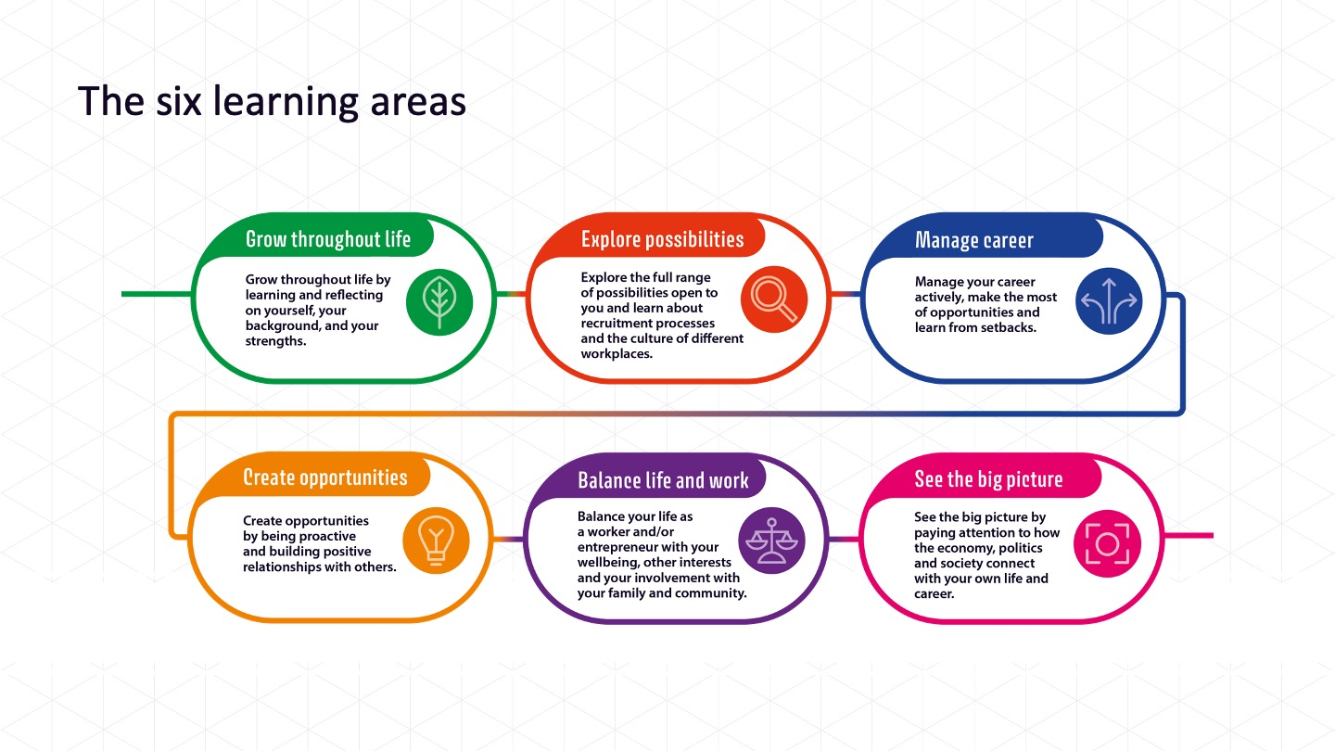

Good careers provision means that all pupils can see for themselves and their peers the high level of aspirations that there are throughout all of the school.

**Our Commitment**

• We will use the school website, emails and social media to promote careers and careers events to parents, carers, students and employers.

• All students from Year 7 upwards have the opportunity for a guidance interview or activity with a Careers Advisor or a member of staff who can offer quality and impartial advice. We will work alongside third parties, including Local Authorities to facilitate this.

• All students will achieve their true potential whilst being fully prepared for their transition into the changing world of work. We will work towards a whole school approach, ensuring that staff, parents and students are aware of our vision. Staff will be encouraged to undertake careers related CPD.

• We are committed to achieving all of the eight [Gatsby Benchmarks](https://www.careersandenterprise.co.uk/schools-colleges/gatsby-benchmarks) and following the [CDI Career Development Framework](https://www.thecdi.net/new-career-development-framework) (select the links for further information).

**Our Vision**

• Our aim is to empower students with meaningful employability skills and resilience. We will provide and teach how to research local, national and international labour market information as well as post 16 and post 18 pathways and we will work to ensure that transitions are fully managed. We will continue to engage with students once they have left through our Alumni “Aspire”.

• Our Careers Programme and Policy will be published on the school website and there will opportunity for students, staff, parents and employer partners to offer feedback.

• To have a body of Student Career Ambassadors (consisting of students and Alumni) who consult on the career resources, both online and through in school meetings.

• We will work to ensure that all students have work experience placements and employer engagements, either as part of our internal Intern Programme or outside of school as outlined in the Careers Programme.

* We will provide up to date LMI. By doing this we aim to actively encourage all students and their families and HMS staff to think about the future pathways of each and every student. Students will be encouraged to be active in developing their own LMI (for example when on School trips). when on School trips, thinking about and talking about the different job roles seen or that are “behind the scenes”. Talking to family about jobs. Thinking about the jobs seen when watching television. Research! We are aiming to provide current relevant career and labour market information (LMI), this could include information on:
* Financial skills
* Trainee, internship and apprenticeships
* Further Educational settings and future study options
* Career pathways and how to get on them
* Salaries

The Careers Policy has the explicit backing of the Senior Leadership Team and is approved by the Board of Governors.

The following people have responsibility for this Careers Policy:

Lorna Davies-Bailey: Executive Head Teacher

Email: [Lorna.Davies-Bailey@ofgl.co.uk](mailto:Lorna.Davies-Bailey@ofgl.co.uk)

Telephone: 01895 813679

Emma Cobbold: EHCP & Transition Officer, Careers Lead

Email: [emma.cobbold@hmschool.org.uk](mailto:emma.cobbold@hmschool.org.uk)

Telephone: 01895 813679

[To be assigned]: School Governor for Careers

Email:

Telephone:

Date written: March 2021

Last reviewed: September 2023

Next review date: September 2024